# CS 255 System Design Document Template

This template lays out all the different sections that you need to complete for Project Two. Each section has guidance to prompt your thinking. You will need to continually reference the interview transcript as you work to make sure that you are addressing your client’s needs. There is no required length for the final document. Instead the goal is to complete each section based on what your client’s needs are. Remove this note when you are finished, and replace all bracketed text with the relevant information.

## UML Diagrams

### UML Use Case Diagram

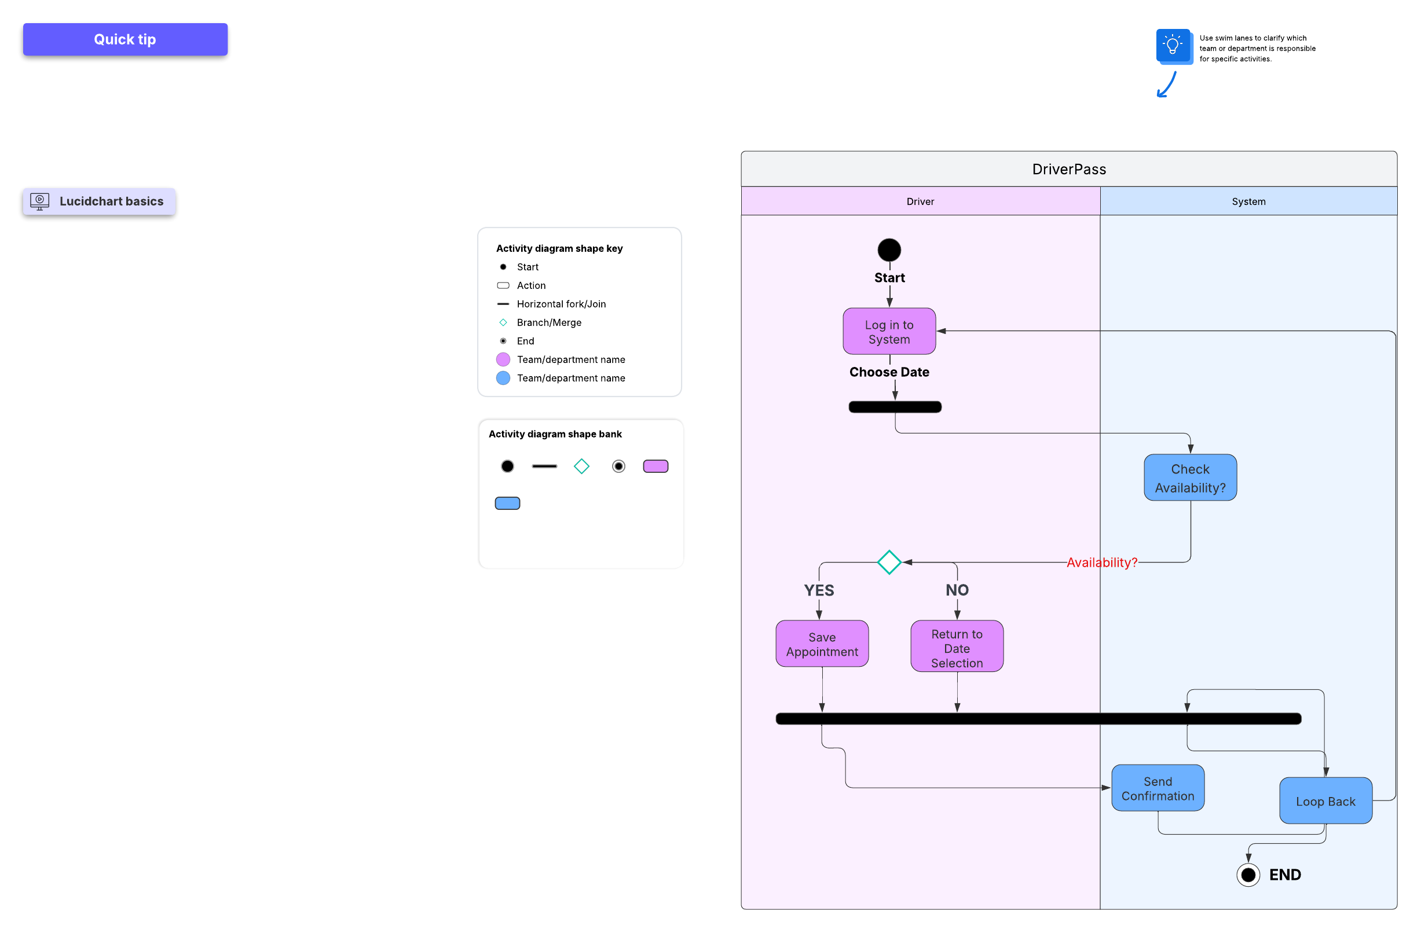

### UML Activity Diagrams

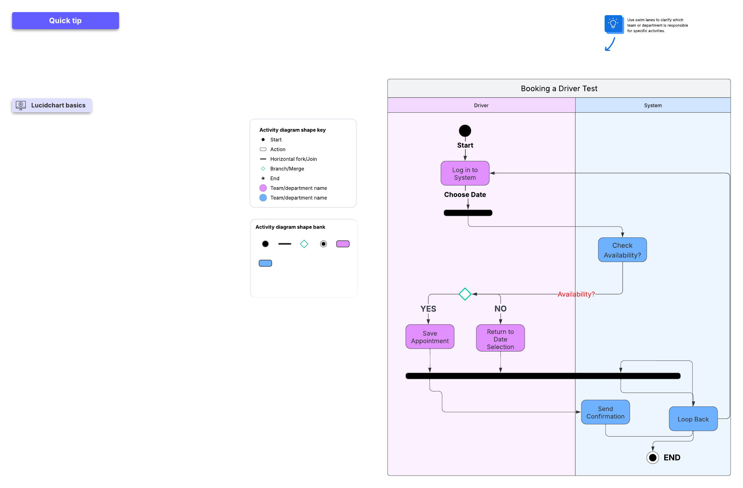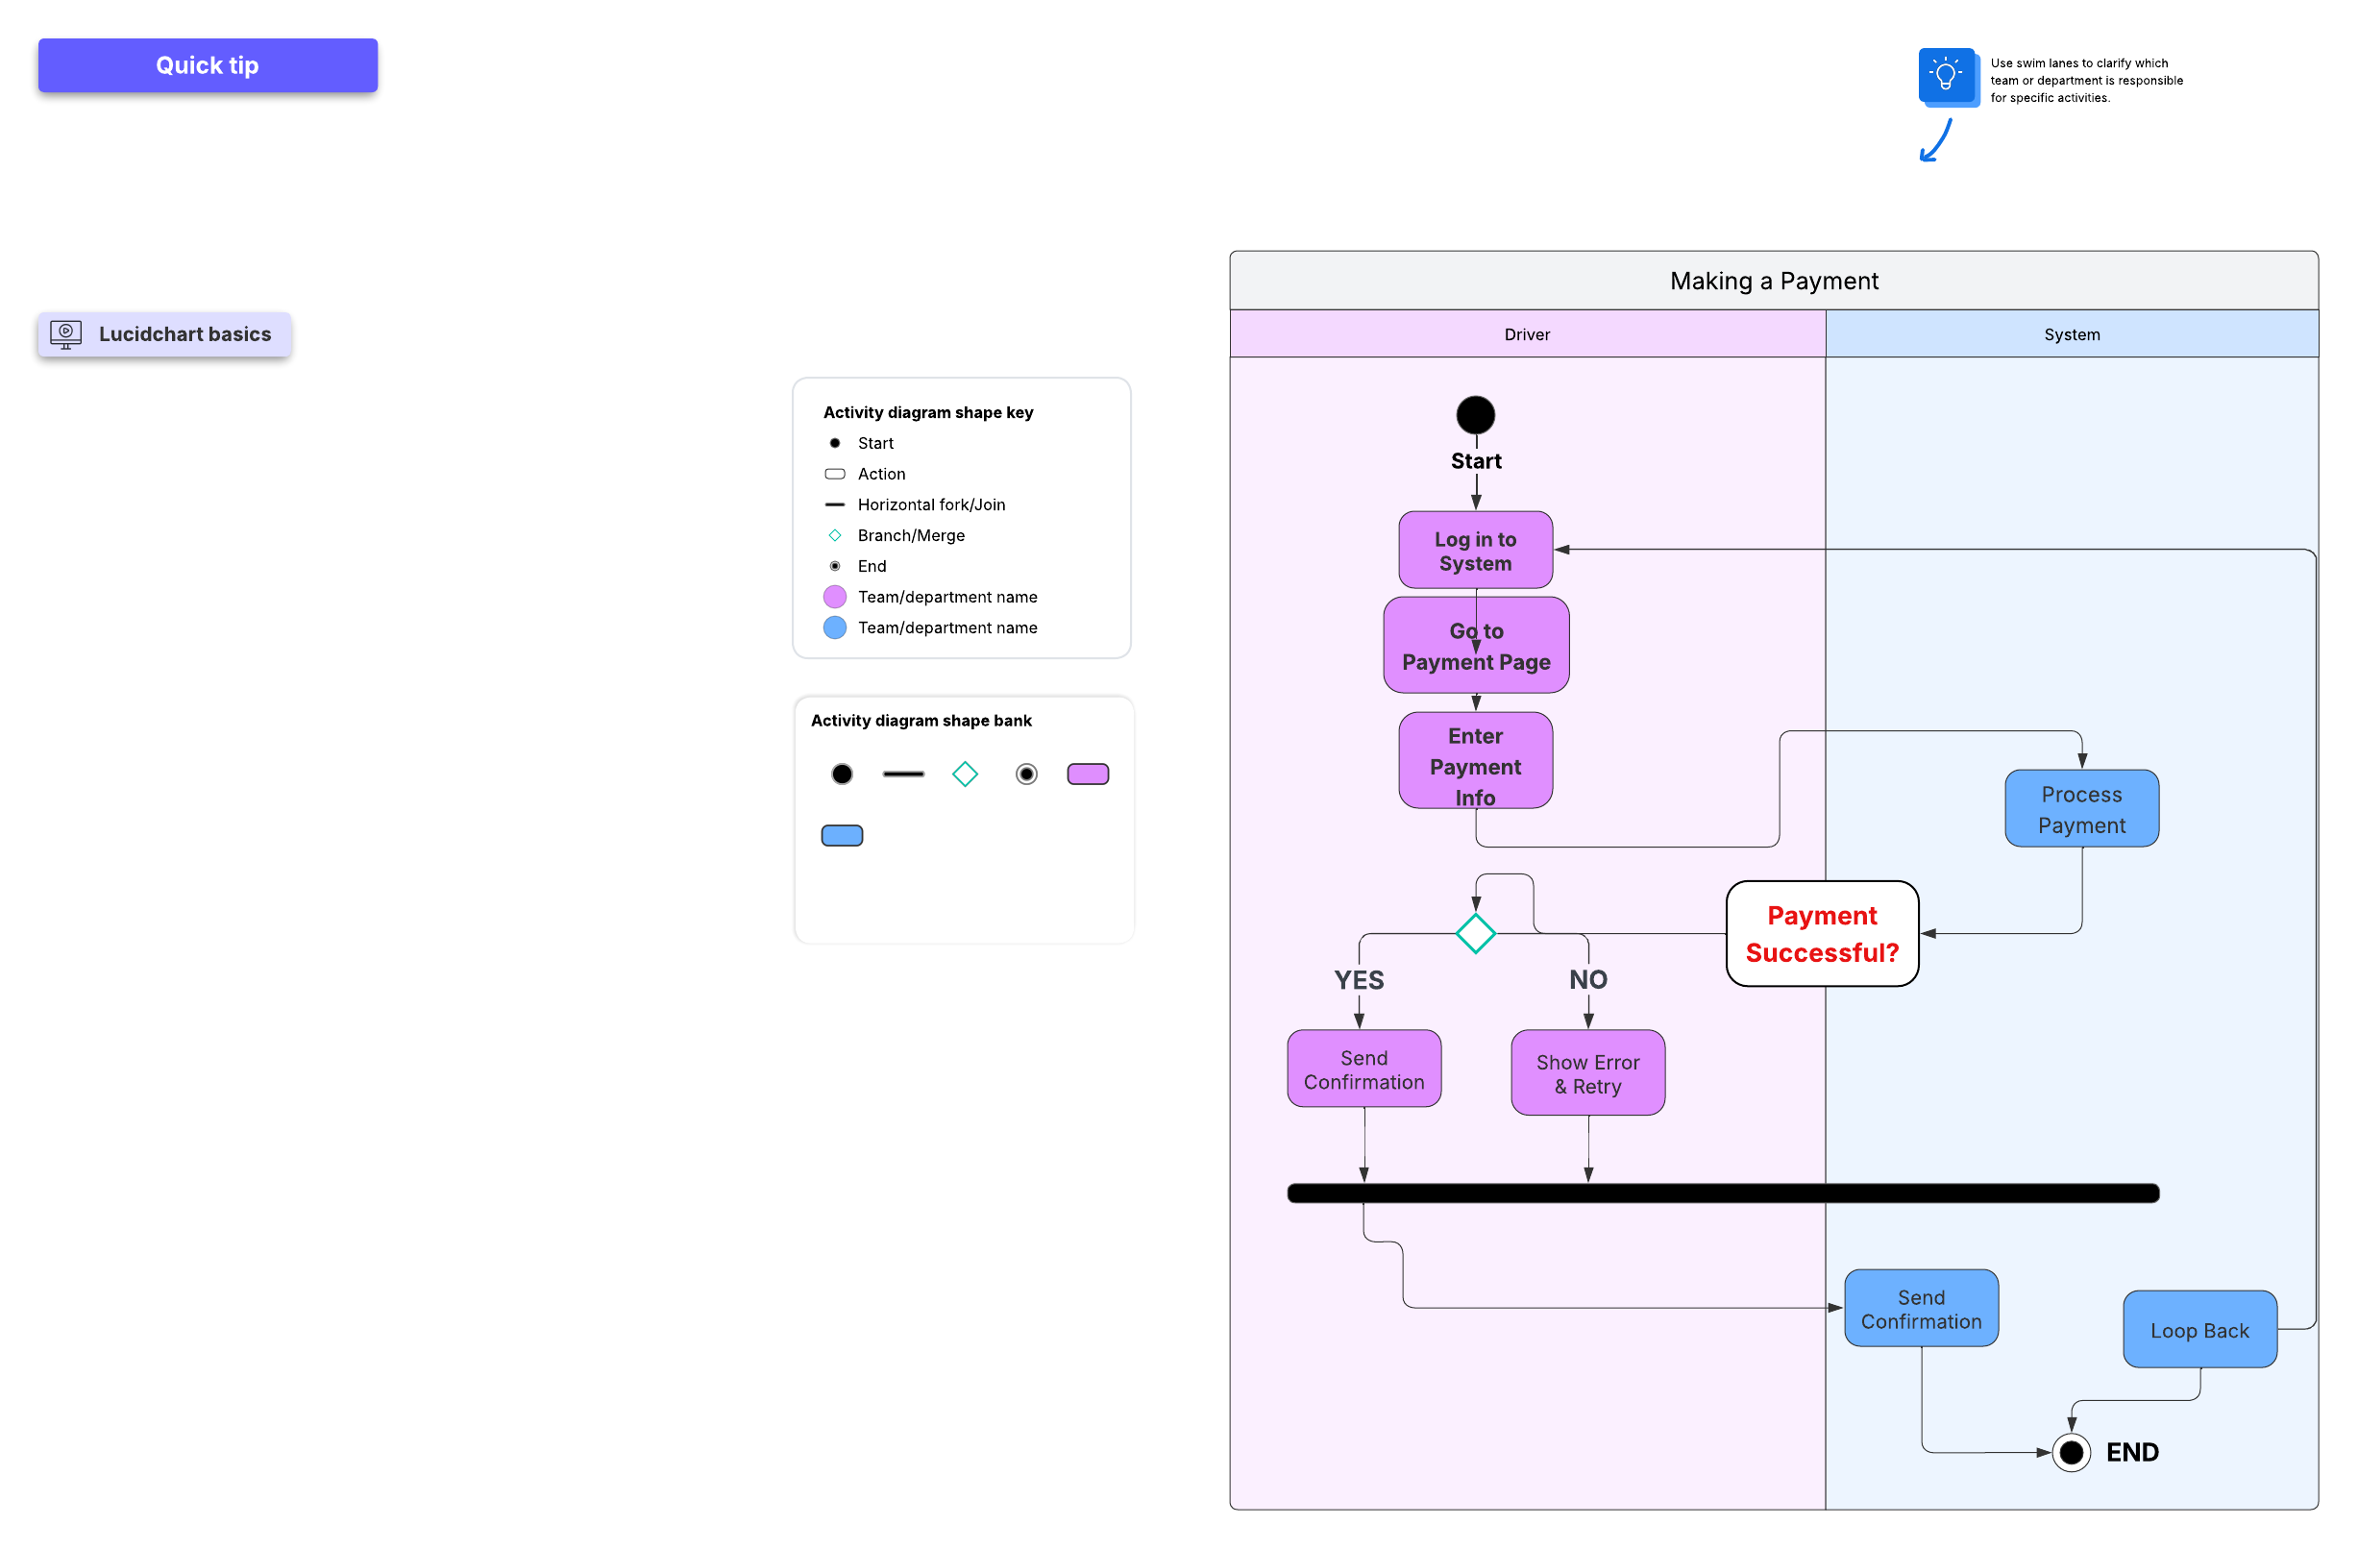

### UML Sequence Diagram

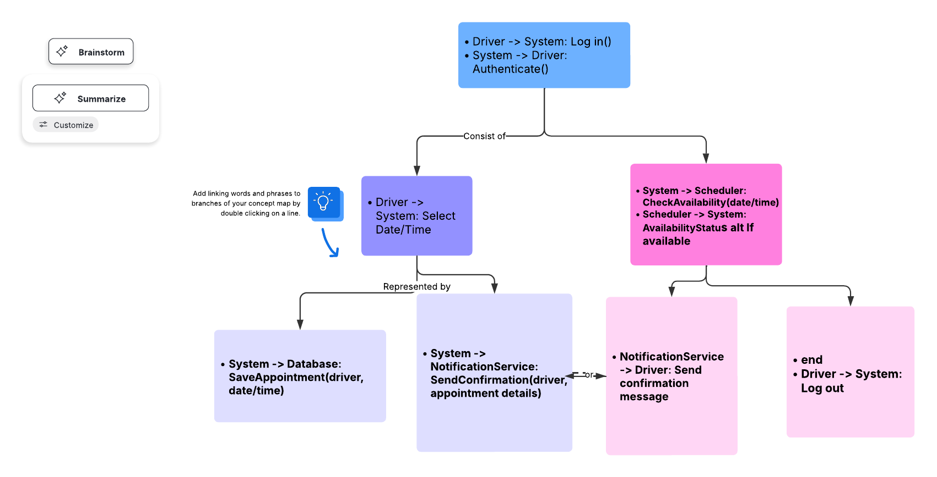

### UML Class Diagram

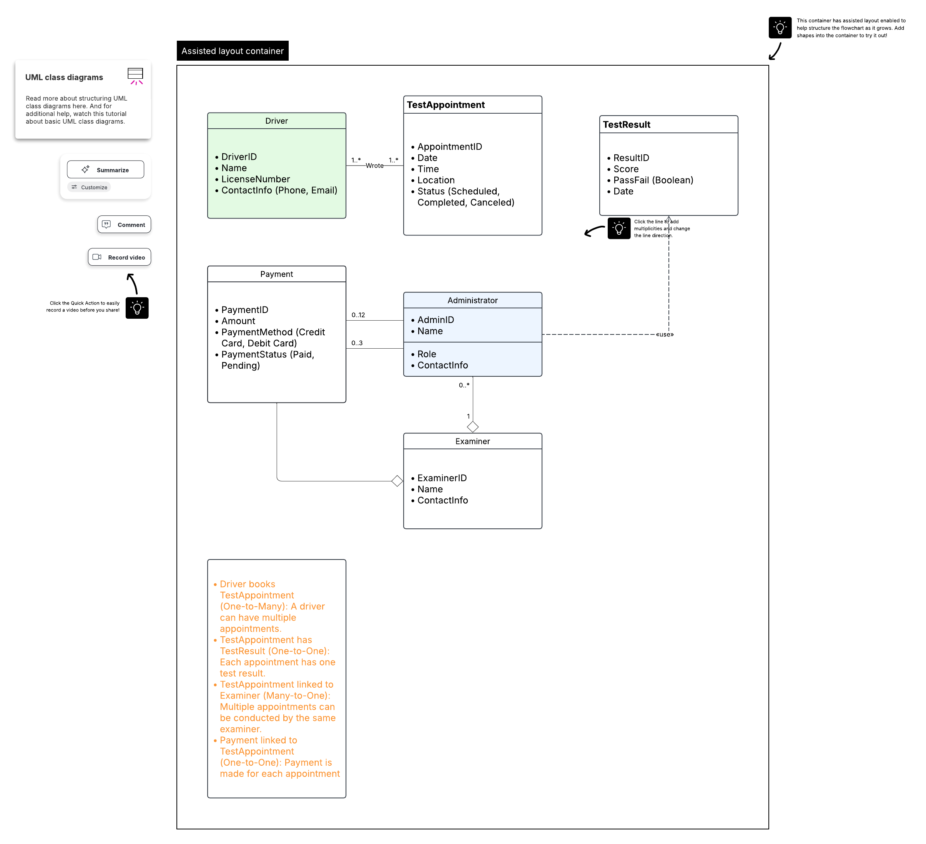

## Technical Requirements

*1. Introduction*

*This document outlines the hardware, software, tools, and infrastructure necessary to develop, deploy, and maintain the DriverPass system, ensuring it operates securely, efficiently, and reliably.*

*2. Hardware Requirements*

*2.1 Server Hardware*

* ***Processor:*** *Minimum 4-core CPU*
* ***Memory:*** *At least 8 GB RAM*
* ***Storage:*** *100 GB SSD or HDD for hosting the application and database*
* ***Network:*** *Reliable high-speed internet connection*
* ***Backup Power Supply:*** *Uninterruptible Power Supply (UPS) recommended for continuous operation*

*2.2 Client Devices*

* ***Devices:*** *Personal computers, tablets, or smartphones*
* ***Operating Systems:*** *Windows, macOS, Linux, Android, iOS*
* ***Connectivity:*** *Stable internet connection for accessing the web-based system*

*3. Software Requirements*

*3.1 Server Operating System*

* *Linux (Ubuntu, CentOS) or Windows Server*

*3.2 Web Server Environment*

* *Apache or Nginx*

*3.3 Database Management System*

* *MySQL or PostgreSQL (preferred open-source options)*

*3.4 Application Development Languages*

* *Front-end: HTML, CSS, JavaScript*
* *Back-end: Python, Java, PHP, or Node.js (based on team expertise)*

*3.5 Development Tools*

* *IDEs: Visual Studio Code, IntelliJ IDEA, Eclipse*
* *Version Control: Git with repositories hosted on platforms like GitHub or GitLab*

*3.6 UML Modeling Tools*

* *Lucidchart or similar diagramming tools for designing and maintaining UML diagrams*

*4. Tools and Infrastructure*

*4.1 Security*

* *SSL/TLS certificates for secure data transmission*
* *User authentication protocols (e.g., OAuth 2.0)*
* *Data encryption for sensitive information*

*4.2 Payment Processing*

* *Integration with secure payment gateways like Stripe, PayPal, or Square*

*4.3 Backup and Recovery*

* *Automated daily backups of databases and application files*
* *Cloud storage solutions (e.g., AWS S3, Google Cloud Storage) for backups*

*4.4 Monitoring & Maintenance*

* *System monitoring tools (e.g., Nagios, New Relic)*
* *Regular updates and security patches*

*5. Network and Security Infrastructure*

* *Firewall configurations to restrict unauthorized access*
* *VPN access for administrative operations*
* *Intrusion detection systems (IDS) to monitor suspicious activities*

*6. Additional Considerations*

* *Scalability options to accommodate future growth*
* *Load balancing for high availability*
* *Data privacy compliance (e.g., GDPR, local regulations)*